School of Business Leadership: Research Focus Areas 2024

Admission requirements for Doctoral of Business Leadership qualification
Graduate School of Business Leadership
- Introduction
This document provides the selection criteria applicable to the Doctoral in Business Leadership (DBL) qualification offered by the Graduate School of Business Leadership (SBL).
These selection criteria consist of the following:
Students' applications will be reviewed following the Procedures for Master's and Doctoral Degrees (section 3.1 to section 3.3). The college is not obliged to accept prospective students who meet the minimum criteria, as other factors are considered. See below
- The entrance requirements for students in the Graduate School of Business Leadership (to ensure that the quality of incoming students is such that they have an optimal chance of completing their qualifications). Meeting the minimum requirements
- The topic the student wishes to research
- The topic alignment with the preferred research focus area
- The college's capacity and expertise to supervise specific areas of research specialisation.
- Academic record
- Limitations imposed by enrolment planning
- The philosophy underlying the selection criteria
The SBL recognises that the opportunity to increase the rate of student throughput in DBL studies begins with the selection and admission process. Recruiting talented candidates from diverse backgrounds with the potential to succeed requires a process that will attract those likely to thrive within the business school culture. In addition, a 'fit' or 'match' between the potential candidate's research interest and the supervisor's expertise is also a key requirement. The selection criteria for DBL candidates are thus founded on the following two pillars:
  - A transparent, fair, realistic and academically well-founded admission procedure
  - Creating a good fit between the DBL candidate's research interest and the supervisor's expertise
In line with UNISA practice, the SBL is convinced that the number of Doctoral registrations should be informed by the availability of suitable supervisors to ensure that available supervisory capacity is not exceeded. There is a need to maintain supervisor/student ratios conducive to high-quality results. The SBL implements various interventions to improve internal supervision capacity to plan for growth. In addition, SBL has embarked on a process to identify what the school offers regarding high-level research expertise and supervision capacity. The focus in SBL is to increase the number of DBL registrations in key research areas in line with current research focus areas and supervisors' areas of specialisation. The SBL offers a Doctoral of Business Leadership, and therefore studies should be differentiated from other colleges through topics focussing on Leadership.
This process:
- assists the matching between prospective DBL candidates and its capacity before admitting a candidate
- Proposed selection criteria for Doctoral studies in SBL
The DBL programme has been structured to significantly guide and support selected students to contribute to business and leadership studies. The DBL takes 2‐6 years to complete. The DBL candidates should attend the compulsory Research Workshops in the first year. The outcome of the research module is an approved research proposal within one academic year. After the research module has been approved, candidates are officially registered for the thesis.
The admission criteria for the Doctoral programme at the SBL are informed by the UNISA Admissions Policy and section 37 of the Higher Education Act 101 of 1997 (as amended), which states the following:
37. Admission to public higher education institutions
(1) Subject to this Act, the council of a public higher education institution, after consulting the senate of the public higher education institution, determines the admission policy of the public higher education institution.
(2) The council must publish the admission policy and make it available on request.
(3) The admission policy of a public higher education institution must provide appropriate measures for the redress of past inequalities and may not unfairly discriminate in any way.
(4) Subject to this Act, the council may, with the approval of the senate—
(a) determine entrance requirements in respect of particular higher education programmes;
(b) determine the number of students who may be admitted for a particular higher education programme and the manner of their selection;
(c) determine the minimum requirements for re-admission to study at the public higher education institution concerned; and
(d) refuse re-admission to a student who fails to satisfy such minimum requirements for re-admission.
The SBL acknowledges the importance of the italicised phrase in subsection (3) above and will adopt a very flexible approach regarding admission to doctoral studies. Responsible, feasible, flexible and transparent selection criteria will promote proper and effective management of postgraduate students in the Graduate School of Business Leadership. For this reason, the selection criteria identified by the SBL aim to foster inclusivity instead of being prescriptive and exclusionary.
Admission criteria for the DBL degree:
A student:
- Must hold a three-year Bachelor's degree with 360 SAQA credits and an MBL or MBA, or equivalent Management or Leadership degree from an approved tertiary institution. Relevant working experience will be an added advantage;
- Could be requested by the Graduate School of Business Leadership (SBL) to pass one or more departmental examinations or to complete additional MBL or MBA modules if deemed necessary;
- Must submit a 2,500-word research outline (in line with the requirements listed below), original certified copies of academic records as well as a Curriculum Vitae;
- Has to apply for admission using the Unisa online application system at www.unisa.ac.za/md/applications
Prospective DBL candidates will be considered for admission to the respective research focus areas of the college. The initial selection of candidates for Doctoral studies will be done through the assessment of the research outline (maximum of 2,500 words) describing the following:
- Topic
- Description of the problem to be addressed
- Literature review indicating the gap in the literature and the possible contribution to new knowledge
- Significance and impact of the desired outcome locally, on the continent and/or globally
- List of references (using the Harvard referencing method) of recent, e.g. past five years, scholarly sources and seminal authors.
The following criteria will be applied equally to assess the research outline:
- Academic merit: Quality in originality, significance, rigour and impacts in reach and significance.
- Evidence of higher-order thinking: The candidate's skills and abilities in analysing, synthesising, applying, and evaluating information.
- Writing skills: The extent to which the outline conveys coherent and well-developed arguments that are supported with relevant, detailed and convincing evidence; the logical sequence of paragraphs with content-based transitions; the use of appropriate diction and tone, constructively varied sentence structures and the use of correct grammar, punctuation, spelling and syntax.
- Academic and professional experience: Strengths and relevance relative to the candidate's opportunities (impact).
To prepare the outline, the SBL proposes the following course of action to the candidate:
- Read scholarly articles based on the problem to be researched for at least a year before applying for a DBL
- Acquire and study Acquire the textbook "Stepping stones to achieving your doctorate" by Trafford and Lesham
- Request temporary access to the library from the Post Graduate Studies Manager at the SBL (vdpolhm@unisa.ac.za)
- Read a substantial number, at least 50, of current (2018-2022) scholarly articles based on your idea of a researchable problem. You can classify this into a table containing authors, problem statements, findings, and suggestions for future research. This will assist in identifying the gap in the field
- You can contact a possible supervisor from the focus areas below and bounce ideas.
Short-listed candidates should meet with potential supervisors and present their outlines in person at a workshop or via an electronic medium such as SKYPE or MS Teams as part of the selection process.
Successful candidates will be informed in writing that they may register for the DBL proposal module. The names of unsuccessful candidates and the reasons for their rejection will be submitted to the SBL Quality Assurance and Planning Committee for validation. Applicants can appeal to the College Executive Management if admission is refused. Reasons for such refusal must be furnished to the applicant.
The following possible alternative opportunities exist for applicants who do not meet the generic admission requirements for SBL:
  - Applicants with degrees that have different structures from normal South African MBL/MBA degrees, applicants whose degrees do not correspond to generic SBL admission requirements (e.g. no mark awarded for previous dissertations, no clear evidence of having completed a research-related module as part of the previous qualification, etc.), or applicants who do not meet generic admission requirements but who have applicable experience in research that may qualify them for admissions to a DBL degree will be required to apply for recognition of prior learning (RPL). Prior academic and research activity by the applicant will be evaluated in accordance with formal Unisa RPL procedures, and the outcome of the RPL process will be submitted to and approved by the SBL Executive Committee. If the approved outcome of the RPL process is positive, the applicant will be allowed to proceed with an application for admission, subject to all terms and conditions governing the admissions process.
  - Students who have been refused admission because of limited capacity within the SBL may reapply in subsequent years.
  - In instances where a student has a weak academic record, a submission may be made to the Academic Director to allow such a student admission. Students must provide a written motivation of no more than three pages requesting admission to the SBL. The SBL will consider the application considering the following:
    - the relevant experience, work or otherwise, of the student
    - alternative options for access to the programme
    - any other factor deemed necessary by the SBL.

- Model of Supervision
Students will be allocated to a supervisor but should work independently within the requirements of higher degree studies.
Students are encouraged to pursue their research in the listed research focus areas below. However, competition for a space in the programme is severe, and it is the candidate's responsibility to convince the selection panel that his/her research outline is worthy of research.
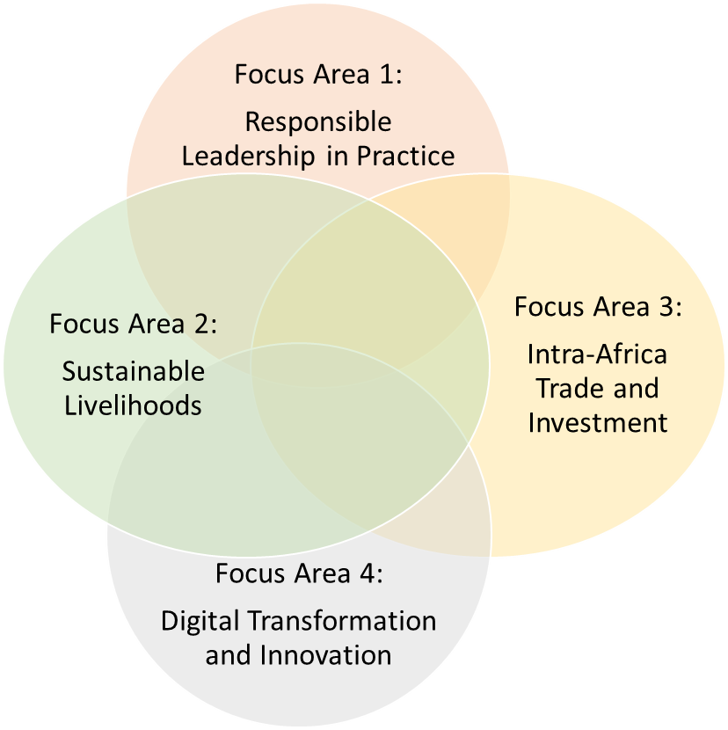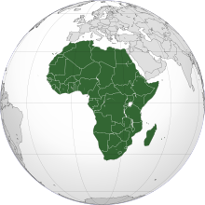
Focus area | Short description of the focus area | The lead researcher (contact person) | Capacity per focus area/research team
Responsible Leadership in Practice
This focus area focuses on leaders in business or public sector organisations and how Leadership is practised in these organisations
Business ethics and Corporate Social Responsibility | Focus areas are crystallised in: Standards of business behaviour; Advancing the effectiveness of ethics policies and programmes; Embedding ethical values and behaviours; Women breaking 'glass ceilings'; The Ethicality of Women as Leaders in Corporations and Public Service; Corporate ethics; Ethics and risk; Corporate social responsibility; Corporate sustainability; Ethical norms in international business; Ethics and leadership (e.g. charisma, manipulation, persuasion); Organisational ethics; Managers' moral decision-making; Learning and critical management perspective; CRS studies; Developing sustainable, ethical business practices. | Prof A Nicolaides  Email: pythagoras13@hotmail.com | Doctorates: up to 12
Ethics and Governance | Today, we speak of the interconnected future of business and society. For instance, the successful implementation of the national development plan is arguably necessary for the sustainable development of business. However, in the South African context, we have also seen a wide array of governance public and private sector failures and how their impact has compromised the sustainability of key public and private sector institutions as well as effective delivery of services as highlighted by the work of the Zondo Commission of Enquiry into State Capture, whose reports (Volumes 1-4) are worth reading. Consequently, therefore, the focus is on the following:  - Governance, national and foreign anti-corruption laws and risk management, building integrity systems, corporate social responsibility & sustainability management theories and related governance frameworks  - The application of human rights standards and the bill of rights concepts to the corporate governance discourse and the extent to which they may be used as a tool for evaluating the performance of businesses and articulating further the role of business in society, especially how businesses ought to be governed.  - Ethical Leadership and governance of ethics  The focus is thus on Corporate governance, human rights and company law; human rights; corporate social responsibility and human rights, stakeholder management and human rights; and sustainability management & human rights | Prof S Monyamane  Email: monyas@unisa.ac.za | Doctorates: up to 2
Innovation Behaviour | Seeking a deeper understanding of the human behaviour that contributes to the functioning of organisational systems. More specifically, their ability to act innovatively towards the growth and sustainability of the organisational systems they function in while understanding the dynamics of these organisational systems (processes and procedures) towards designing for the enhanced emergence of innovation behaviour. | Dr C Hind  Email: hindc@unisa.ac.za | Doctorates: up to 4
African Leadership | Organisational Leadership in the African context, specifically its role and contribution to organisational climate/culture, and its impact on organisational and employee behaviour, through the utilisation of the meso-framework. Instrument design and validation form the technical basis for many studies to ensure that the contextual realities are acknowledged and accounted for. This entails a mixed-method approach, usually from an emic perspective. | Prof A Grobler  Email: grobla@unisa.ac.za | Doctorates: up to 2
Strategic processes and Practices | In this research focus area, the focus is on how strategies are shaped, managed and used by humans in organisations. Strategists (individuals and teams), their networks (e.g. external consultants), the tools they use, and their colleagues and employees are the focus rather than the economic characteristics of strategy. | Prof P Venter  Email: ventep@unisa.ac.za | Doctorates: up to 13
Leadership and Organisational Behaviour | Leadership and Organisational Behaviour revolve around studying and applying knowledge about how individuals and teams behave in organizations. At the Graduate School of Business Leadership, the focus is often on how leaders behave and the effect thereof. The behaviour could be analysed at micro, meso and macro levels and often requires a systematic approach. Specific focus areas include the effects of Leadership on innovation and system psychodynamic theory. | Prof R Steyn  Email: steynr@unisa.ac.za | Doctorates: up to 15
Women in Leadership | Research focuses on various topics within the broader field of women in Leadership. Current studies use qualitative research and the intersectional lens, amongst others, focusing on gender transformation, workplace bullying and sexual harassment. | Prof PP Mnguni  Email: mngunpp@unisa.ac.za | Doctorates: up to 3
Higher Education Leadership | A multidisciplinary research area. Higher Education Institutions (HEI) have become complex organisations. In recent times, many have failed to meet the expectations of their stakeholders. Research is required to develop an understanding of the failures as well as the best practices for leading HEIs. With a rapidly changing global and national context, more formalised knowledge is required to enable leaders to steer HEIs better. Areas of research include leading Research and Innovation, Learning and Teaching and Community Engagement. | Prof L Labuschagne  Email: LLabus@unisa.ac.za | Doctorates: up to 2
Sustainable livelihoods
This focus area is dedicated to contributing to sustainability in general and to our better understanding of sustainable economies, industries, business and management practices
Sustainability marketing | The domain of Sustainability Marketing and business practices emerged due to the recent business and climate crisis resulted in the growing concern for sustainability. Organisations are not aloof of these changes as they are trying to incorporate these environmental and social issues into their practices. It is important to understand that sustainability marketing as departure from profit-oriented conventional marketing and business practices.  This focus area explores, investigates and covers Green marketing; Cause-related marketing; Marketing and Society; sustainability orientation and practices of organizations (public and private sector); Sustainable consumption and the role of Sustainable Development Goals (SDG)’s in the areas of food, water, and energy consumption; Sustainable consumer behaviour and practices like collaborative consumption, sharing economy, and circular economy; Consumer policy and sustainability; sustainable tourism; SDG 4 and sustainability management education.  Besides the main areas, collaborative co-supervision is provided in research in the areas of Sustainable project management and Sustainable supply chain area. | Prof N Purushottam  Email: purusn@unisa.ac.za | Doctorates: up to 4-6. It varies year to year, and as students complete
Finance and Financial management in Africa | The focus area covers corporate finance, international finance, and economic and business development, including SMME financing. | Prof MF Tshehla  Email: tshehlmf@unisa.ac.za | Doctorates: up to 10
Program and Project Management | Topics covered in this focus area include infrastructure procurement and management of risks and contracts management, project appraisal, project planning, procurement, contract formulation and management, project performance evaluation and strategic project management | Prof MF Tshehla  Email: tshehlmf@unisa.ac.za | Doctorates: up to 21
Supply Chain Management | The focus area covers the following: Sustainable supply chain, digitisation of supply chain, vulnerability and resilience analysis of supply chain (including supply chain management risks), and Ethics and governance in the supply chain. | Prof MF Tshehla  Email: tshehlmf@unisa.ac.za | Doctorates: up to 7
Microfinance and SMEs Development | This research area focuses on SME development, microfinance for SMEs, and SMEs' challenges. | Prof MF Tshehla  Email: tshehlmf@unisa.ac.za | Doctorates: up to 8
Quality and operations management in Africa | The research focuses on quality and operations management, particularly improving organisational efficiency, which ensures profitability and sustainability, in shaping an effective organisation. Operations Management is an effective organisation's hallmark, facilitating improved performance and ensuring organisational success. The focus group consists of Operations, Quality and Risk Management to improve organisational effectiveness and sustainability. | Dr S. Naidoo  Email: naidoosu@unisa.ac.za | Doctorates: up to 5
Intra-Africa Trade and Investment
This focus area focuses on South Africa's place on the continent and globally. It is dedicated to improving intra-African trade and investment and our better understanding of Africa and South Africa's role in the developing world.
African and global economies and Markets | This research area focuses on the following:  - Sectoral Economic Analysis  - Institutional economics  - Agricultural economic analysis  - Natural resource economics (Water, Land, etc.)  - Local and regional economic development issues | Dr Muchara  Email: muchab@unisa.ac.za | Doctorates: up to 6
Digital Transformation and Innovation
The focus area focuses on the ICT revolution and how concepts like artificial intelligence, the fourth industrial revolution, and the Internet of things are changing industries, businesses and business practices. It incorporates the use of big data and blockchains in enhancing strategic decision-making
 | This focus area undertakes teaching and learning, research and publication, postgraduate supervision, and community engagement projects on how the Fourth Industrial Revolution (4IR) and associated digital technologies – Artificial Intelligence (AI), Internet of Things (IoT), Big Data Analytics, etc. – can be exploited to advance South Africa and the rest of the continent's economic fortunes. | Prof M Malatji  Email: malatm1@unisa.ac.za | Doctorates: up to 26

